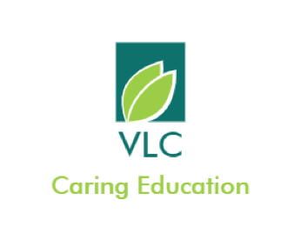

Parent/Carer and Student Guidance for Remote Teaching and Learning, Video Conferencing and Phone Learning Help

What a strange time we are in! We want you to know that here at VLC, we are here for you.

Here is some guidance about what will happen if your child needs to isolate or if VLC is forced to close its centres for a short time period.

At VLC, we understand that learning for our pupils might need to look a bit different for each of you. We therefore have some different choices through which you can receive the learning for your child

Work will be set through one the following means:
- Email – this should be through staff VLC accounts and sent to the student VLC account
- MyMaths
- Paper copy of work delivered to home address by post or by hand

Set work will be supported through one the following means:
- Phone conversation to parents
- Phone conversation with the pupil
- Microsoft Teams Lesson
- Door step explanation

Contacting us:

Here are the phone numbers and email addresses for the key staff members at VLC:
Amanda (Principal and Whitnash A): 07307862985
Karen (office): 07340 820763
Edel (Whitnash B): 07307859602
Amy (Whitnash C): 07307862173
Pam (Rugby):
Trudie (Shottery): 07988173475

You may receive phone calls from other staff members during this time, but will only be able to contact us through the numbers above.

Email:

Your child will be given a VLC email address and MyMaths logon. Please contact you centre leader if you are not able to access these. Please do be aware that all email exchanges will be saved.

Door Step Visits:

We will let you know if we intend to pop around with work. Please do ensure that you keep a social distance from staff. Unfortunately, staff will not be able to enter your home at this time. Do feel free to ask questions about how to complete the work.

Work which is posted:
Please do call us if your child needs help with any work we have posted. We are happy to help on the phone or by email.

Video Lessons:
You child will need to down load the Microsoft Teams App if they are to access Video learning. The need to use their VLC email address so that we can invite them.

For everyone’s safety, we request the following:
- During 1:1 video lessons 2 VLC staff may be present. Please be aware that there will be another staff member in the background on any 1:1 video calls. Please also note that the member of staff may request that the student turn off their camera for safety reasons.
- We request that everyone dresses appropriately for video calls – no pjs allowed. Our normal VLC dress code must be followed.
- We ask that pupils keep their door open during a call
- Our normal behaviour and safeguarding policies apply of all video calls. The staff have the right to end a call at no notice if needed

Phone Help:
Most of the time (just like our welfare checks) it is preferable to use a parent phone in order to speak with pupils to help them with their learning. If this is not possible, please let the teacher know and we will use the student phone with your permission and only at times agreed with yourself.

Safeguarding:

At VLC every member of staff is here to keep our pupils safe. Every member of staff is highly trained.
There are also specially allocated staff members with additional training to help with this. They are:
Amanda
Pam
Trudie

